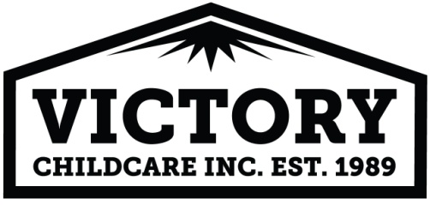

Permission to Apply Over-the-Counter Ointment

I/We ________________________________________, parent(s)/guardian(s) of my/our child(ren) ____________________________________, so give permission for the staff of Victory Child Care, Inc. to apply over-the-counter suntan lotion, lotions and creams for dry skin and OTC First Aid Anti-biotic Cream.

_________________________________________________________ ________________________
Parent/Guardian Signature Date

